
Exploring the Virtual Rainforest Name: ________________________
Fact Hunt – Find Your Answers in the Virtual Rainforest

What kind of bird drinks nectar? ________________________________________________

What kind of bird eats fruit? ________________________________________________

What do Howler Monkeys like to eat? ________________________________________________

What is one kind of venomous snake? ________________________________________________

Which frog lives on the ground? ________________________________________________

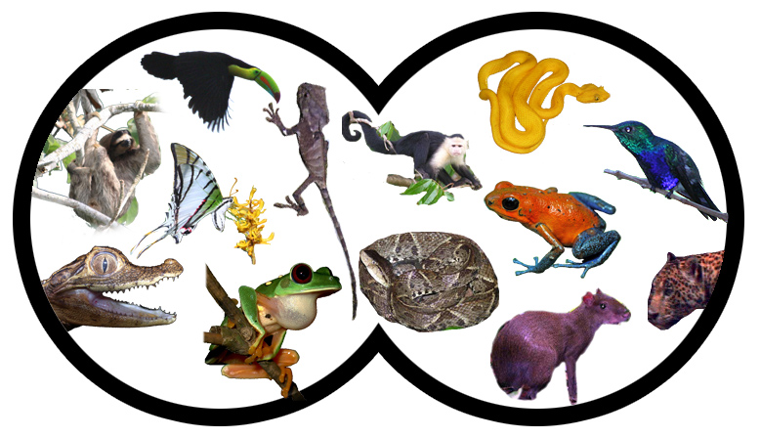 | In your binoculars you can see lots of animals. Circle all the animals in the picture that like to live in the trees.
Draw a food chain including SEEDS, JAGUARS, and AGOUTIS to show which one eats which other one.

What group of insects has the most species?
ANTS or BEETLES or BUTTERFLIES

